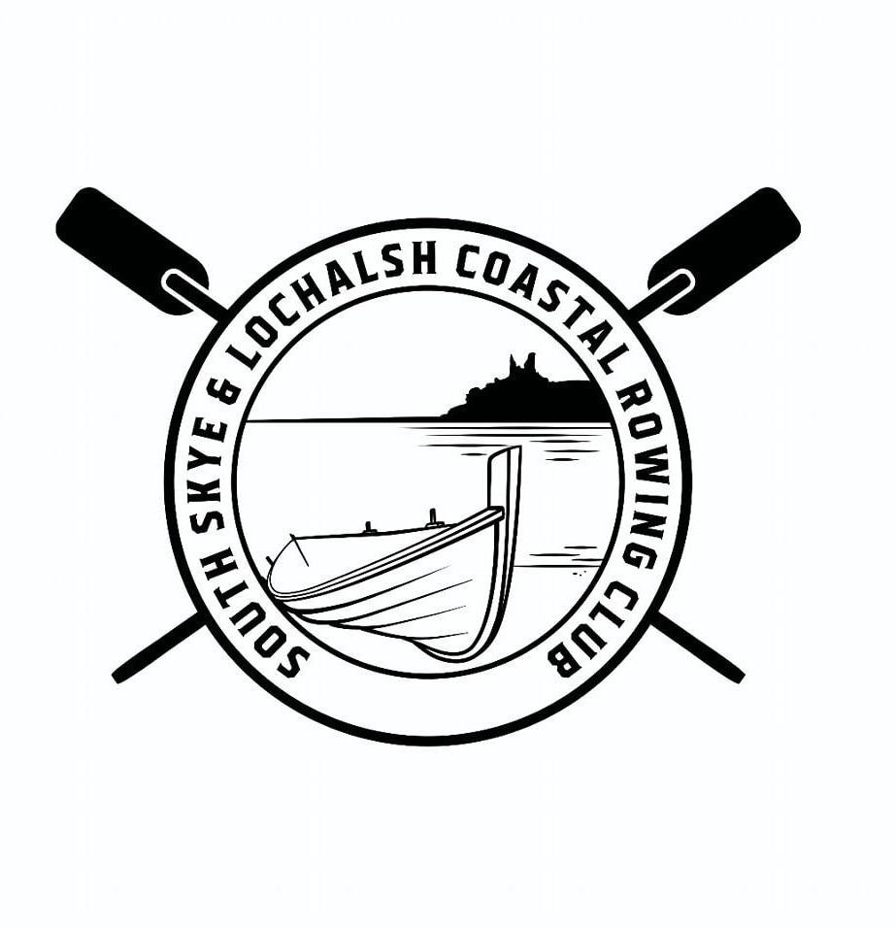
South Skye and Lochalsh Coastal Rowing Club
Buidheann Iomraidh an Eilean‘s Loch Aillse
DAY MEMBERSHIP

Facebook page: South Skye and Lochalsh Coastal Rowing

Full Name:
Address (including post code)
Telephone no: | Emergency Contact name & number:
E-mail address:
Are you content to receive emails from the Club? Yes/No
(please circle)
Membership Category
Day Member : Free |  | Date of row:  Membership is valid for this date only

CONFIRMATION AND WAIVER
- I confirm that I am voluntarily participating in the row and I understand the physical demands and inherent risks associated with my participation. I confirm that I have no medical condition which would prevent me from being physically capable of participating in the row.
- I acknowledge that rowing involves certain risks, including, but not limited to, physical injury, accidents, or other harm, and I assume full responsibility for any such risks.
- I agree to follow all instructions and guidance given to me during the row (including launch and return of the boat).
- I hereby release, discharge, and hold harmless the Club and its members from any and all claims, actions, or liabilities for personal injury, death, or property damage arising out of my participation in the row.
- I agree to indemnify and hold harmless the Club and its members from any claims or expenses arising out of my participation in the row.
Please note that the Club has insurance which covers the boat and associated equipment, member to member insurance and third party liability insurance.

By signing below, I acknowledge that I have read, understand and voluntarily accept the terms of this confirmation and waiver.

Please complete and return to southskyeandlochalshrowing@gmail.com
Signature:
Date:

