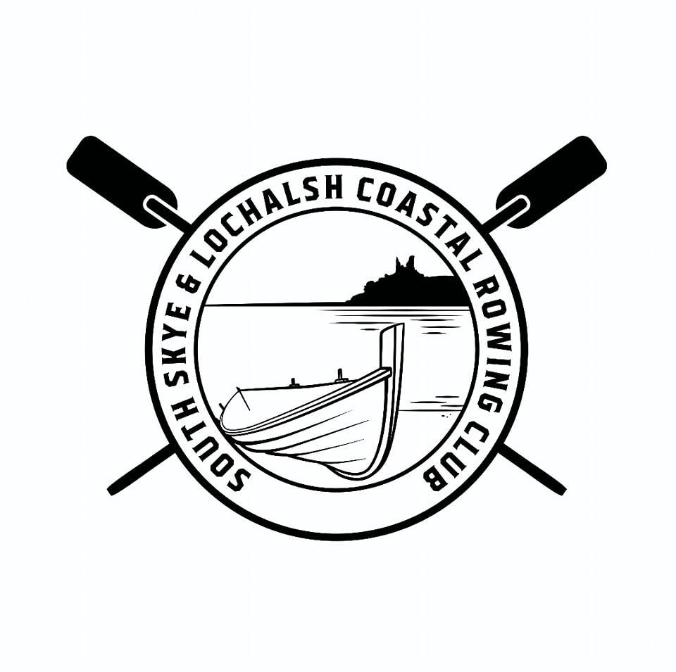

South Skye and Lochalsh
Coastal Rowing Club
Buidheann Iomraidh an Eilean ‘s Loch Aillse

Email: southskyeandlochalshrowing@gmail.com
Facebook page: South Skye and Lochalsh Coastal Rowing
Web: southskyelochalshcoastalrowing.co.uk

Full Name:

Address (including post code)

Telephone no: | Emergency Contact name & number:
E-mail address:

Are you happy to receive emails from the Club? Yes/No
Are you happy that club photos you appear in are shared on website
and club social media pages? Yes/No

Membership Category – Please circle the appropriate box
Rowing Member  £45 |  | Junior  16 -17  Free | Social (non-rowing) Member  £25

Please pay via bank transfer to our account at Virgin Money
South Skye & Lochalsh Coastal Rowing Club
Please make sure you put your name in the reference box.
Sort code: 82 67 18 | Account Number: 50017442

Membership: Membership is open to all ages over 16 and all abilities. Membership entitles you to join the rows organised by the Club at no additional cost, in accordance with current booking arrangements. Training is offered to all rowing members on a periodic basis and we strongly recommend that you attend.

Please note that the Club has insurance which covers the boat and associated equipment, member to member insurance and third party liability insurance.

For more Membership information, please see the Members section on our website.

CONFIRMATION AND WAIVER
- I confirm that I will be voluntarily participating in all rows and I understand the physical demands and inherent risks associated with my participation. I confirm that I have no medical condition which would prevent me from being physically capable of participating in a row and I agree to update the Club if my medical situation changes and would affect my physical ability to participate in a row.
- I acknowledge that rowing involves certain risks, including, but not limited to, physical injury, accidents, or other harm, and I assume full responsibility for any such risks.
- I agree to follow all instructions and guidance given to me during rows (including launch and return of the boat) and all safety information issued by the Club (by email, whatsapp or on the Club’s website).
- I hereby release, discharge, and hold harmless the Club and its members from any and all claims, actions, or liabilities for personal injury, death, or property damage arising out of my membership or participation in rows.
- I agree to indemnify and hold harmless the Club and its members from any claims or expenses arising out of my membership or participation in rows.
By signing below, I acknowledge that I have read, understand and voluntarily accept the terms of this confirmation and waiver. I agree to abide by the constitution, code of conduct, rules, policies and procedures of the Club (as set out on the website or sent to members by email or the Club’s whatsapp group).

Signature:
Date:

The membership year will run for 12 months from date of joining.
Please complete and return to southskyeandlochalshrowing@gmail.com

